Contents

Exercise 1 2

Exercise 2 3

Exercise 3 4

Exercise 4 5

Exercise 5 6

# Exercise 1

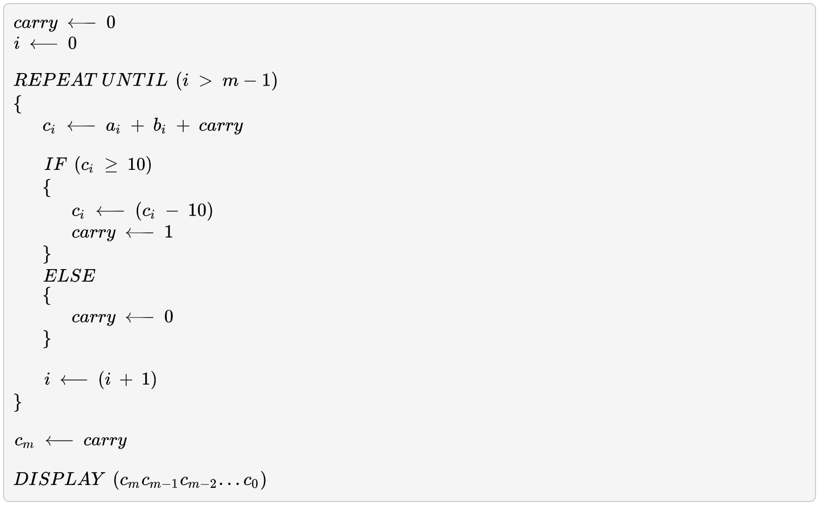

For each value of i, trace the algorithm and fill in the table below using the sample inputs. There are two columns for ci, carry, and i. The first column is where you put their respective values before the IF statement. The second column is where you put their respective values after the IF statement. In the last row, put the final value of carry (i.e., right before the DISPLAY statement).



|  |  |  |  |  |  |  |  |
| --- | --- | --- | --- | --- | --- | --- | --- |
| *i* | *a­i* | *bi* | *carry* | *ci* | *ci* | *carry* | *i* |
| 0 | 3 | 7 | 0 | 10 | 0 | 1 | 1 |
| 1 | 2 | 6 | 1 | 9 | 9 | 0 | 2 |
| 2 | 9 | 5 | 0 | 14 | 4 | 0 | 3 |
| 3 | *N/A* | *N/A* | *1* | *N/A* | *N/A* | *N/A* | *N/A* |

# Exercise 2

# Exercise 3

# Exercise 4

# Exercise 5

